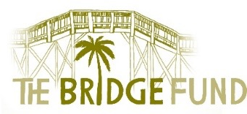

REQUEST FORM FOR BRIDGE FUND ASSISTANCE

Submit to: Beverly Haas, BeverlyVHaas@gmail.com, 617-645-4165; or backup Michael Beebe, mbeebe@aol.com, 239-682-3855; or Jim Herald, jrh8719@aol.com, 317-727-7698

Please send as a Word document. We cannot accept a PDF or photocopy of this form.

Date:

School Name:

School Contact Name and Position:

Contact Phone #: Contact Email:

A. SUMMARY OF NEED

1) Name of person(s) needing assistance (or group to benefit if school request):

2) Specific Need (rent, electric bill, MRI, car repair, education, etc.):

3) How many persons will benefit if this request is approved?

4) One time need?: Yes ____ No____; Have we assisted before? Yes ____ No____ (if Yes, explain under B, below)

5) Total funds required to meet need: $

6) Other agencies or possible resources also contacted:

7) Funds to be provided from any other source: $

8) Total funds requested from The Bridge Fund: $

B. BACKGROUND DESCRIPTION OF NEED (Include what caused this immediate need, i.e., lost job, medical problem, etc. and, if applicable, what are the plans for self-sufficiency in the future)

C. PAYMENT DETAILS

1) Date funds needed:

2) If approved, please note how funds to be paid
Please provide name, address and phone number of payee:
(Include copies of an invoice or lease, or description of order and delivery instructions, as appropriate)

_______________________________________________________
For Bridge Fund use only.

Request approved: denied: Date: Amount:

