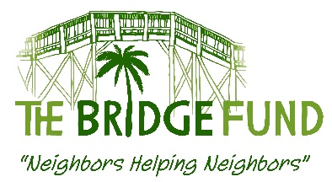

REQUEST FORM FOR BRIDGE FUND ASSISTANCE

Submit to: Beverly Haas, BeverlyVHaasTBF@gmail.com, 617-645-4165
or to Michael Beebe, mbeebe@aol.com, 239-682-3855

Please submit as a Word document. We cannot accept a PDF or photocopy of this form.

Please answer all questions

Date:

School Name:

School Contact Name and Position:

Contact Phone #: Contact Email:

A. SUMMARY OF NEED

1) Name of person(s) needing assistance:

2) Specific Need (rent, electric bill, MRI, car repair, education, etc.):

3) How many persons will benefit if this request is approved? _____ Adults; _____ children

4) Is this a one-time need? Yes ____ No____;

Has person/family received help from TBF or any other agency or charity within the past year? Yes ____ No____

If Yes, please describe here:

5) Total funds required to meet need: $

6) Other agencies or possible resources also contacted. For agencies or charities, include contact name when possible and result.

7) Funds to be provided from any other source, including person needing assistance: $

8) Total funds requested from The Bridge Fund: $

B. BACKGROUND DESCRIPTION OF NEED
1) What caused this immediate need (i.e., lost job, medical problem, etc.)?

2) What are the plans for self-sufficiency in the future?

C. PAYMENT DETAILS

1) Date funds needed:

2) Please provide payment or delivery instructions (where and to whom payment to be made, including account number and payee phone number).
3) Please provide a copy of an invoice, lease, or other documentation that supports the funds needed.

_______________________________________________________
For Bridge Fund use only.

Request approved: denied: Date: Amount:

