A Special Project of The Bridge Fund

Salam Alaikum is a Pashto/Farsi greeting that several Bridge Fund volunteers used frequently for the first six months in 2022.

Beginning in August 2021, the Department of Homeland Security (DHS) lead and coordinated ongoing efforts across the federal government to support vulnerable Afghans, including those who worked alongside us in Afghanistan for the past two decades, as they safely resettle in the United States. In late 2021, some of these Afghan families were brought into the Lee County area, assisted by Lutheran Services Florida (LSF).

When needed, The Bridge Fund (TBF) will create projects to serve unusual situations such as this. To assist in this local effort, TBF established the Afghan Refugee Resettlement Project (ARRP) in partnership with the LSF office in Ft. Myers.

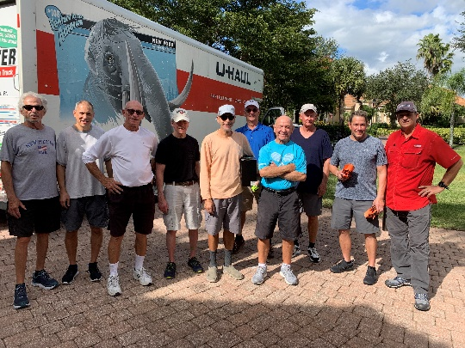
As the refugees arrived, LSF arranged for their housing and other basic needs. ARRP put together a team of 17 PL/Colony volunteers and rented U-Haul trucks for collecting, transporting, storing, and delivering large quantities of donated furniture, kitchen supplies and other household goods. In some instances, TBF assisted the Afghan refugees with rent and also the purchase of 6 used cars and facilitated the transfer of ownership of two donated vehicles to refugee families.

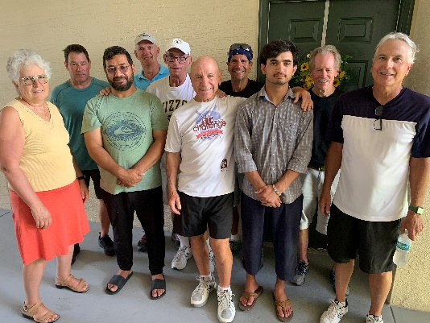
This was about a six month hands-on project that helped roughly 52 individual Afghan refugees (including 9 families) settle into living quarters in Ft. Myers, Lehigh Acres and Cape Coral. TBF continues to assist individuals from these resettled families as specific needs arise.
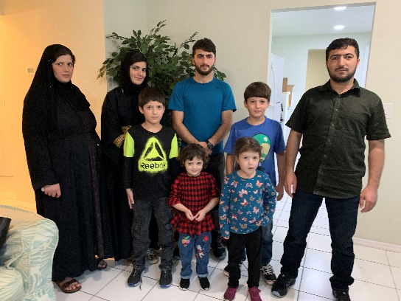

Like many refugees, these Afghans arrived with little more than the clothes on their backs. TBF is proud to have served an important role in helping these individuals and families get settled into their new homes in America.

