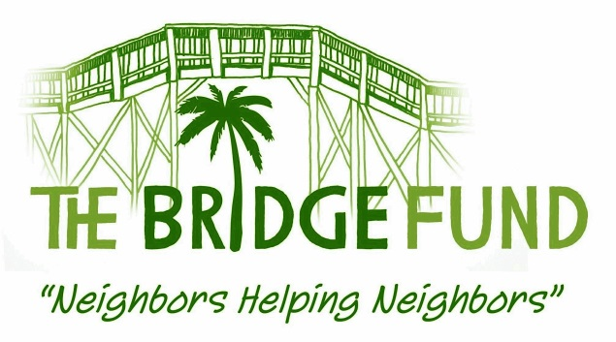

The Bridge Fund
Thanks You
For Your Support!

Name__________________________________________________________

Address________________________________________________________

City, State, ZIP___________________________________________________

Phone______________________Email_______________________________

Enclosed is my check to The Bridge Fund for $_________________________

I wish to remain anonymous ______________(Y/N)

A 501(c)(3) charitable organization supporting the adults
and children of the greater Bonita Springs and Estero communities

Please mail completed form and donation to:

The Bridge Fund
23530 Peppermill Court
Bonita Springs, FL 34134

