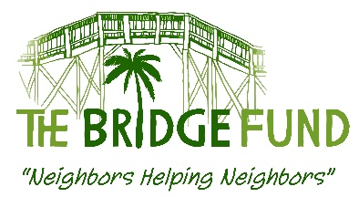

REQUEST FORM FOR BRIDGE FUND ASSISTANCE

Submit to: Beverly Haas, BeverlyVHaas@gmail.com, 617-645-4165
or backup to Michael Beebe, mbeebe@aol.com, 239-682-3855

Please submit as a Word document. We cannot accept a PDF or photocopy of this form.

Please answer all questions

Date:

School Name:

School Contact Name and Position:

Contact Phone #: Contact Email:

A. SUMMARY OF NEED

1) Name of person(s) needing assistance:

2) Specific Need (rent, electric bill, MRI, car repair, education, etc.):

3) How many persons will benefit if this request is approved? _____ Adults; _____ children

4) Is this a one-time need? Yes ____ No____;

Has person/family received help from TBF or any other agency or charity within the past year? Yes ____ No____

If Yes, please describe here:

5) Total funds required to meet need: $

6) Other agencies or possible resources also contacted. For agencies or charities, include contact name when possible and result:

7) Funds to be provided from any other source, including person needing assistance: $

8) Total funds requested from The Bridge Fund: $

B. BACKGROUND DESCRIPTION OF NEED
1) What caused this immediate need (i.e., lost job, medical problem, etc.)?

C. PAYMENT DETAILS. Please provide a copy of an invoice, lease, utility bill, or other documentation.

1) Date funds needed:

2) If approved, please provide payment or delivery instructions:

_______________________________________________________
For Bridge Fund use only.

Request approved: denied: Date: Amount:

